SCRIPTWRITING FOR UNESCO YOUTH HACKHATON 2026

Introduction
Player is about to play relay race in a magical
maze designed as an art commonplace. In order to do that, they must decode
false pictures, fill in the blanks, and others. They must also beat the timer!

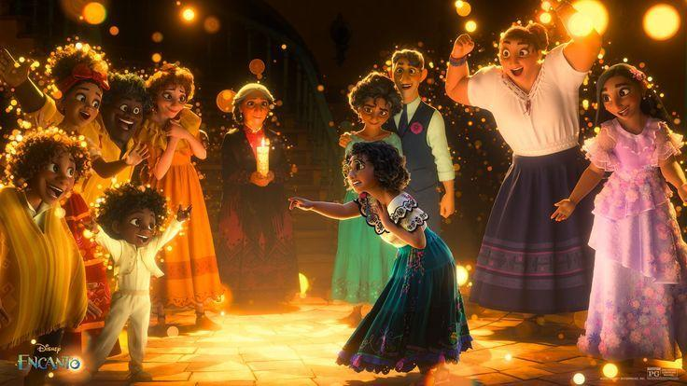
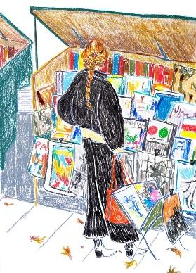
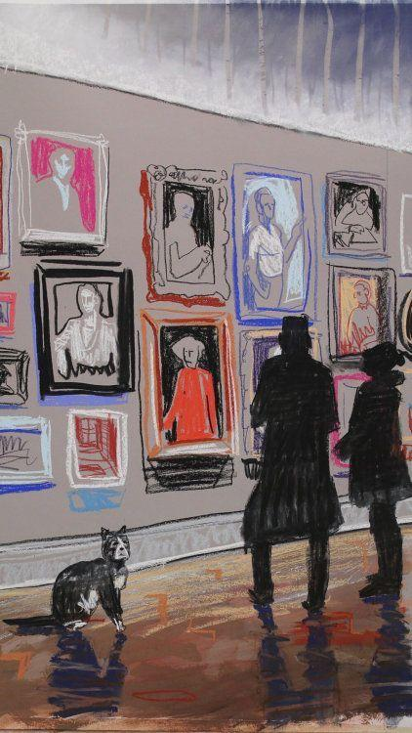
ARTWORK CUE: Warm-toned lighting, starry ambience, crayon-styled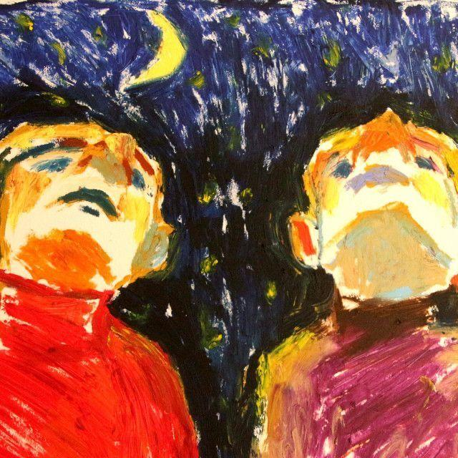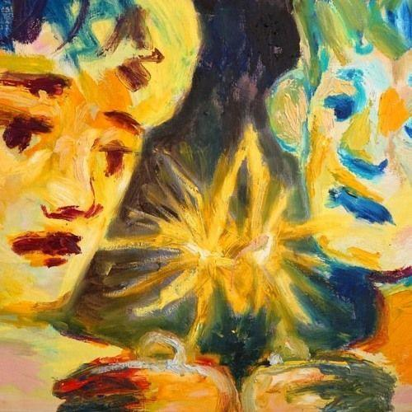
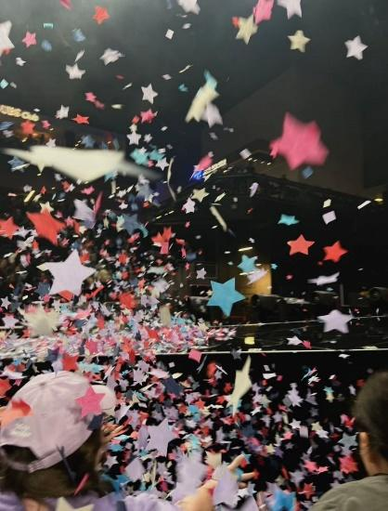

MILLER
Each room in this building is interlocked.
To reach the end of the maze, we must obtain keys.

MILLER
The first one is hidden in the gallery.

MILLER
We must first clear up the space and find it.

MILLER
Eliminate decoys and help me find real art works

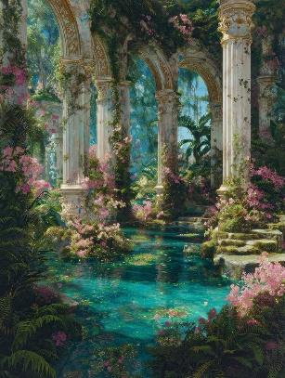
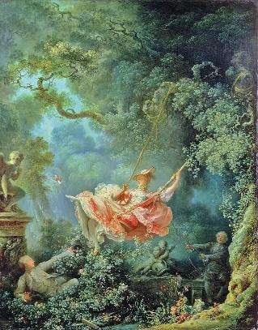
Q1
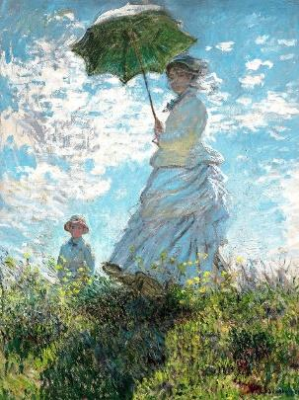
Correct Answer: B (A: Woman with Her Parasal – Claude Monet, C: The Swing – Jean-Honore Fragonard)

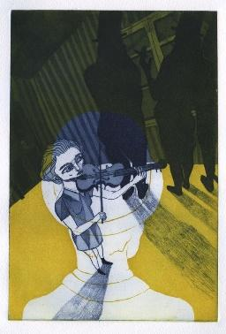
Q2
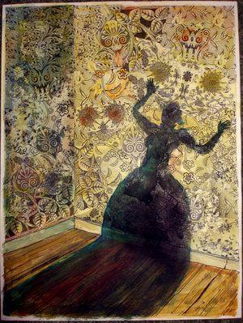
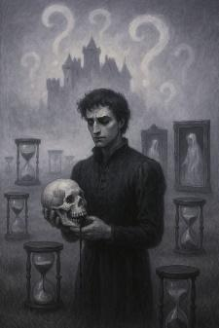

Correct Answer: C (A: The Yellow Wallpaper – Charlotte Perkins Gilman, B: The Metamorphosis – Franz Kafka)

Q3
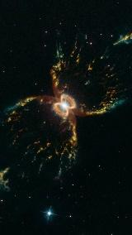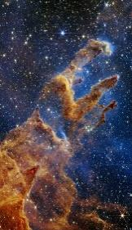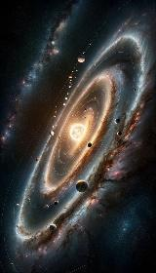
Correct Answer: C (A: NASA Hubble Collections, B: NASA Webb Collections)

Q4
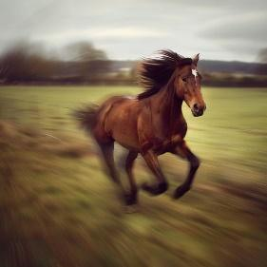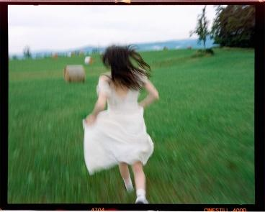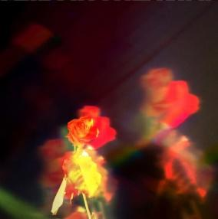
Correct Answer: A

Q5
Chaelint’s drawing works vs 2 AI-Generated pictures

Q6
Other Chaelint’s drawing works vs 2 AI-Generated pictures

STAGE CLEARED!
(I want Miller to obtain his key at this point)

ACCUMULATING TEMPORARY POINTS…

Click Key to Continue

Artwork Cue: Miller transforms into another character (like https://www.youtube.com/watch?v=Bhtv6Lg5YFU)

TIME FOR ROUND 2!

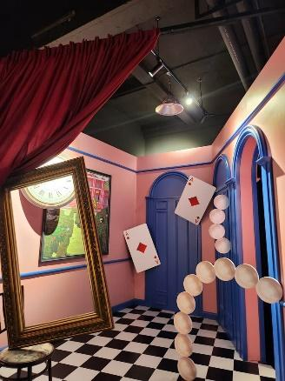
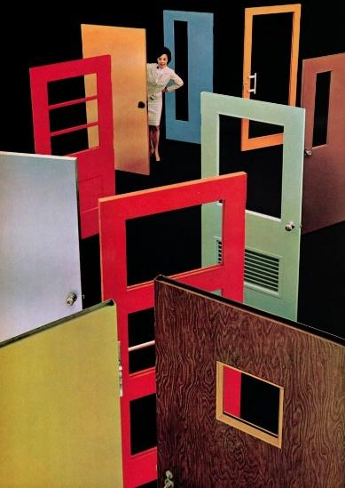
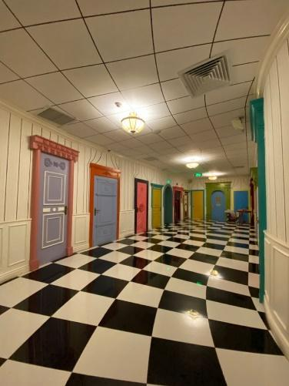
ARTWORK CUE: Wonderland, playground-style interior

JEN
There are too many doors to unlock.

JEN
Only one way to find out.

JEN
Each of these doors contain a password.
Fill in the blanks with the correct options.

- Anne of Green ____ 6. The Lion, The Witch & The ____
- Harry Potter and The _____ of The Phoenix 7. The ___ in Our Stars
- The ____ Runner 8. My Year of ___ and Relaxation
- Gulliver’s ____ 9. Song of The Open ____
- ____ Wood 10. A Brief History of ____
ANSWERS:
- Gables 2. Order 3. Kite 4. Travels 5. Norwegian 6. Wardrobe 7. Fault
8. Rest 9. Road 10. Time

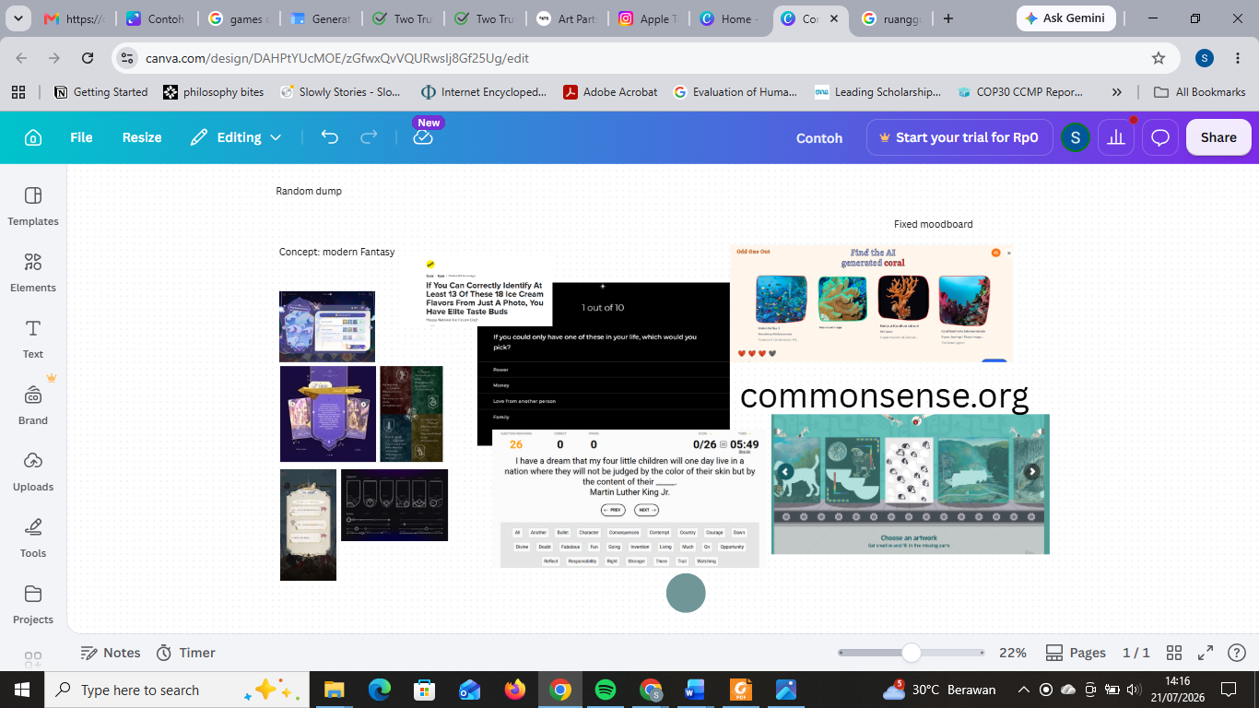

JEN
You got it!
Old ways won’t open new doors!

JEN
Congratulations for your key!

JEN TRANSFORMS INTO ANOTHER CHARACTER (Still the same artwork cue)

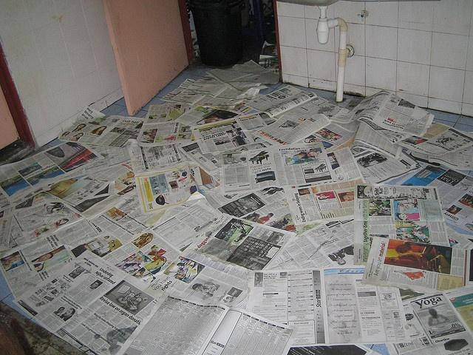
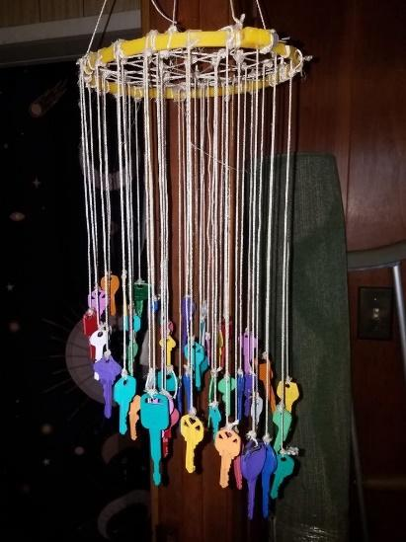
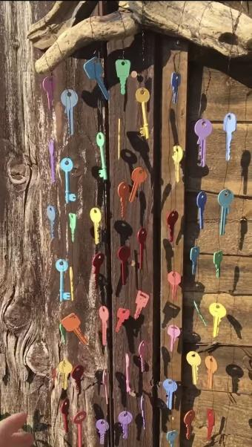
ROUND 3 STARTS
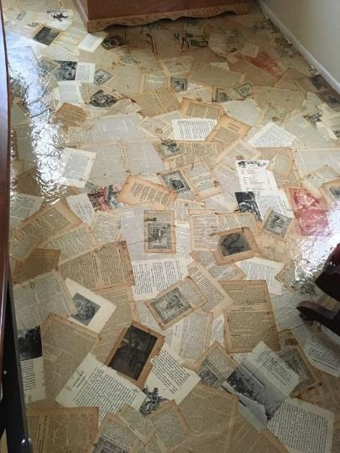

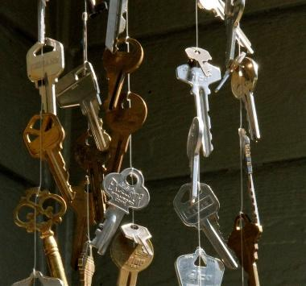
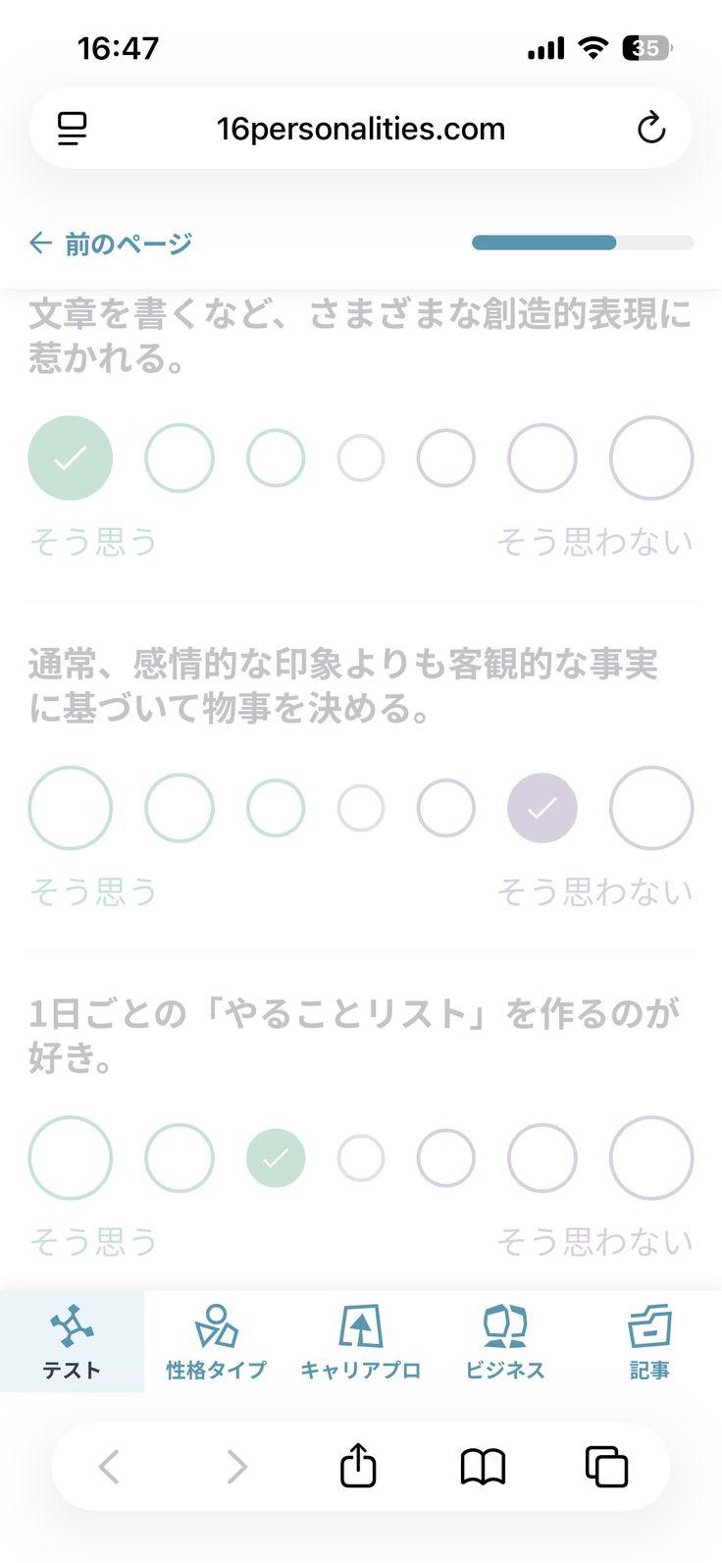

AIDAN
Ah, if this isn’t the key to success….

AIDAN
I figure these letters have clues to our next key

AIDAN
Help me delete letters that do not sound human

Text 1:
Axolotls derive from the same species as salamanders. Whilst being amphibians, their external gills remain aquatic. They reach maturity without significant metamorphosis.
[Human] [Somewhat Human] [Barely Human] [Not Human]

Text 2:
British foods revolve around proteins. A full-on English breakfast have fried egg, bacons, beans and Yorkshire pudding. For lunch, scotched eggs are a common favorite, in a donut shape with breaded sausage.
[Human] [Somewhat Human] [Barely Human] [Not Human]

Text 3:
Valentine’s Day is celebrated every February 14th and is named after Saint Valentine, a Roman priest associated with love and romance. People around the world celebrate their love by exchanging billions of chocolates, flowers, and cards with their loved ones.
[Human] [Somewhat Human] [Barely Human] [Not Human]

Text 4:
In the 1920s, uniforms were often formal and practical, reflecting the fashion and social standards of the time. Many people wore uniforms for work, school, sports, and military service, and these outfits were usually designed to look neat and professional. Uniforms from this era often included structured jackets, skirts or trousers, hats, and polished shoes.
[Human] [Somewhat Human] [Barely Human] [Not Human]

Text 5:
Chopsticks are made around 1200 BCE. Historically, firework became on demand during the Shang dynasty where people had to work quickly. The utensil is made to shorten time when chopping and stirring.
[Human] [Somewhat Human] [Barely Human] [Not Human]

KEY OBTAINED

AIDAN
I see you’ve been reading!

AIDAN
You might be the key player.
The end of the maze is near!

AIDAN TRANSFORMS INTO ANOTHER CHARACTER

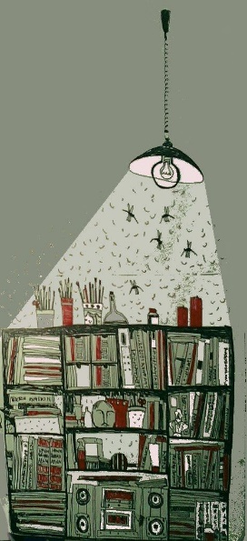
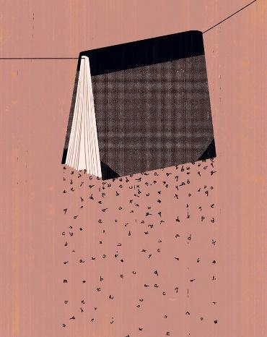
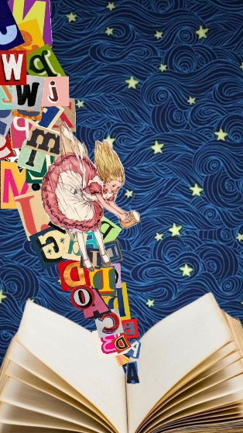
ROUND 4 STARTS

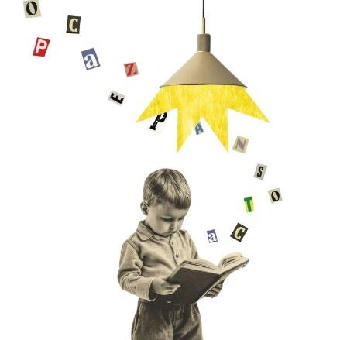

LIZZY
This place is bursting its colors!

LIZZY
We must escape quickly before it lures us into magic!

LIZZY
Choose wisely

- Charlie searches for the Golden Ticket on the edge of a gutter. It has been his only wish, but he could not afford an expensive bar of Wonka chocolate.
What can you get from the text?
- The Golden Ticket is hidden in a bar of Wonka chocolate (3 pts)
- Charlie comes from a poor family (5 pts)
- A Wonka chocolate bar comes in limited edition (0 pts)

- Mrs Honey’s house is the only place where Matilda can read freely. At home, her parents think of it as bizarre; they would be on tantrums.
What can you get from the text?
- Mrs Honey is a relative of Matilda’s (0 pts)
- Matilda’s parents do not share her intelligence (5 pts)
- Matilda performs above average at school (3 pts)

- There has been discourses on the IELTS test. Some say it is a form of discrimination to third world countries as the certification expires in two years. It is studied in the theory of Postcolonialism.
What can you get from the text?
- The IELTS exam is in the expensive side (0 pts)
- One person’s English language skill is seen as interchangeable (3 pts)
- The study of Postcolonialism studies power dominance between countries (5 pts)

- Gastrodiplomacy presents itself in food similarities. For example, Mexican elotes and Indonesian jagung susu keju share the same concept of shredded corn with cheese as dessert.
What can you get from the text?
- Gastrodiplomacy connects countries through culinary knowledge (5 pts)
- Mexican foods share similar culture to Indonesian foods (0 pts)
- Gastrodiplomacy means food similarities (0 pts)

LIZZY
Well done!

LIZZY
We have found all the keys!

LIZZY
Let’s see what happens when I unlock this door…

ARTWORK CUE: A KEY UNLOCKING A DOOR,
LOADING SCREEN,
TEST RESULTS

